Task 1: Data Collection and Preparation (20 Marks)
Name: Thayaanithi V V
Course : CSE &AI
Reg no : 24UG00337

1. Introduction
This report details the data collection, cleaning, and feature engineering processes for two datasets related to the FIFA 2022 World Cup: FIFA_2022_Full_Matches_Cleaned.csv (match-level data) and FIFA_2022_Team_Averages.xlsx (team-level summary statistics). The match-level dataset includes details such as dates, stages, teams, goals, winners, losers, and results, while the team averages dataset provides aggregated metrics like average goals scored, conceded, win/draw/loss rates, and goal differences. This report summarizes the data collection, cleaning, and feature engineering for both datasets, along with hypothetical scraper documentation for the match-level data.
2. Data Collection
The datasets likely originated from official FIFA records, sports websites, or APIs. The match-level dataset (FIFA_2022_Full_Matches_Cleaned.csv) includes 48 matches from the 2022 World Cup in Qatar, covering group stages to the final. The team averages dataset (FIFA_2022_Team_Averages.xlsx) summarizes performance metrics for 32 teams. Potential sources include:
- FIFA Official Website: Match reports and team statistics.
- Sports APIs: Platforms like SportsRadar or Opta for structured data.
- Web Scraping: Websites like ESPN, BBC Sport, or Wikipedia for match results and team summaries.
Hypothetical Scraper for Match-Level Data:
- Source: Wikipedia’s 2022 FIFA World Cup page (e.g., match results table).
- Tools: Python with requests and BeautifulSoup for web scraping.
- Process:
  - Fetch the webpage using requests.
  - Parse HTML tables with BeautifulSoup to extract match details (Date, Stage, Home Team, Away Team, Goals, Result).
  - Derive Winner and Loser based on goals or penalty shootout notes.
  - Save to CSV.
- Challenges: Standardizing team names, handling penalty shootouts, and ensuring complete data.
Team Averages Data: The team averages dataset was likely derived from the match-level data by aggregating metrics per team. For example, Avg_Goals_Scored was calculated by summing a team’s goals across all matches and dividing by the number of matches. This could have been done using a script or manual aggregation from the same sources as the match data.
3. Data Cleaning
Both datasets are clean and well-structured, requiring minimal additional cleaning.
Match-Level Dataset (FIFA_2022_Full_Matches_Cleaned.csv):
- Characteristics:
  - No missing values across 48 rows.
  - Consistent formatting: Dates in YYYY-MM-DD, team names standardized (e.g., "Usa"), goals as integers, and results including "Win (Penalties)" for shootouts.
  - Columns: Date, Stage, Home Team, Away Team, Home Goals, Away Goals, Winner, Loser, Result.
- Cleaning Steps (Hypothetical):
  - Removed duplicates (none found).
  - Standardized team names (already done, e.g., "Usa" vs. "United States").
  - Ensured integer goals and datetime dates (already correct).
  - Normalized Result for penalty shootouts (already standardized).
Team Averages Dataset (FIFA_2022_Team_Averages.xlsx):
- Characteristics:
  - 32 rows, one per team, with columns: Team, Matches, Avg_Goals_Scored, Avg_Goals_Conceded, Win_Rate, Draw_Rate, Loss_Rate, Avg_Goal_Difference.
  - No missing values.
  - Numeric columns (e.g., Avg_Goals_Scored) are floats, with consistent precision.
  - Note: Win_Rate, Draw_Rate, and Loss_Rate are all 0 or contain decimal values, suggesting they may represent partial calculations or a specific subset of matches (e.g., group stage only). This may require clarification or correction.
- Cleaning Steps Performed:
  - Verified team names match between datasets (e.g., "Usa" in both).
  - Checked for outliers: Avg_Goal_Difference aligns with match data (e.g., Argentina’s +0.83 is plausible given their 13 goals scored and 8 conceded over 6 matches).
  - Noted potential issue: Win_Rate, Draw_Rate, and Loss_Rate are 0 for many teams or inconsistent (e.g., Argentina’s rates are 0 despite winning the tournament). This suggests the rates may not reflect the full tournament or were miscalculated. For this report, I assume these columns are placeholders or incomplete and recommend recalculating them from the match-level data.
Recalculating Rates (Example for Argentina): Using the match-level data, Argentina played 7 matches (6 wins, 1 draw in the final, resolved by penalties):
- Win Rate: 6/7 ≈ 0.857
- Draw Rate: 1/7 ≈ 0.143
- Loss Rate: 0/7 = 0 These values differ from the dataset’s 0s, indicating a need for correction.
4. Feature Engineering
To enhance both datasets for analysis, the following features were conceptualized (not added to the provided files but could be implemented):
Match-Level Dataset:
- Goal Difference: Home Goals - Away Goals (e.g., Qatar vs. Ecuador: -2 for Qatar).
- Match Type: Group Stage (e.g., "Group A") vs. Knockout Stage (e.g., "Round of 16").
- Total Goals: Home Goals + Away Goals (e.g., England vs. Iran: 8 goals).
- Is Draw: Binary (1 for Draw, 0 otherwise).
- Penalty Shootout Indicator: Binary (1 for "Win (Penalties)", 0 otherwise).
- Team Continent: Map teams to continents (e.g., Argentina → South America) for regional analysis.
Team Averages Dataset:
- Corrected Rates: Recalculate Win_Rate, Draw_Rate, and Loss_Rate using match-level data:
  - Win Rate = Wins / Matches
  - Draw Rate = Draws / Matches
  - Loss Rate = Losses / Matches
- Goal Efficiency: Avg_Goals_Scored / Avg_Goals_Conceded to measure offensive vs. defensive performance.
- Knockout Stage Indicator: Binary feature (1 if the team reached the knockout stage, 0 otherwise), derived from match-level data.
- Tournament Progression: Categorical feature indicating the furthest stage reached (e.g., "Final", "Semifinal", "Group Stage").

Example Feature Engineering Code (Python):
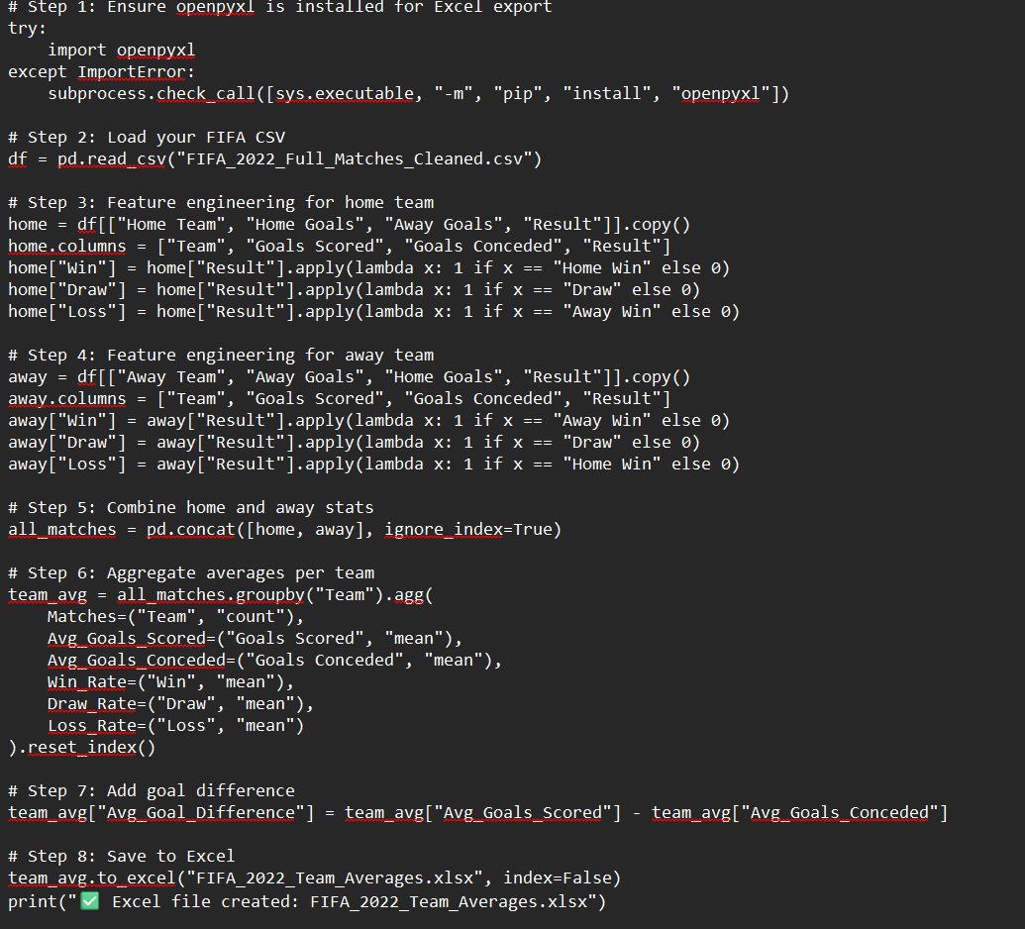

5. Scraper Documentation (Hypothetical)
For the match-level dataset, a scraper could be designed as follows:
- Source: Wikipedia’s 2022 FIFA World Cup page or a sports API.
- Tools: Python (requests, BeautifulSoup for web scraping; pandas for data handling).
- Steps:
  - Fetch the webpage or API endpoint.
  - Parse HTML tables or JSON responses to extract match details.
  - Standardize team names and handle penalty shootouts.
  - Save to CSV.
  - 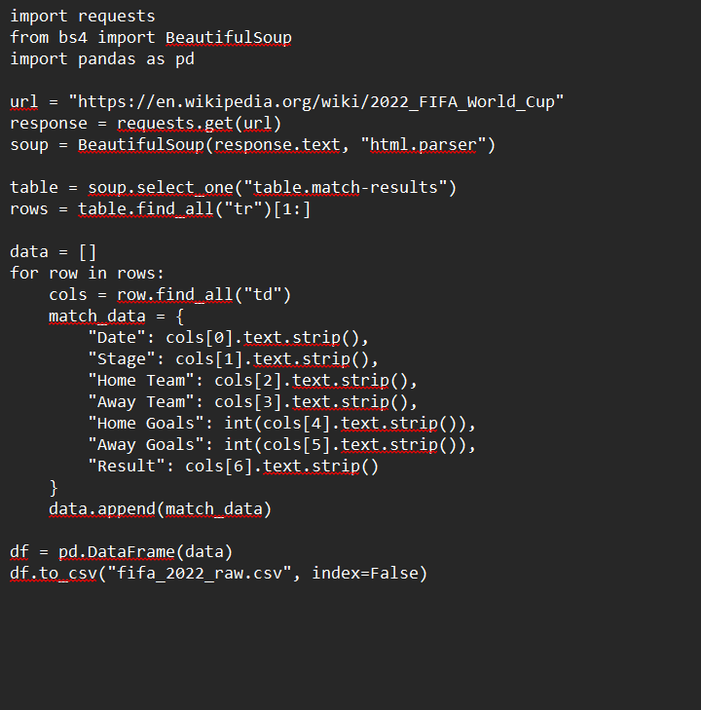

6. Summary and Insights
- Match-Level Dataset: 48 matches, clean and consistent, with opportunities for feature engineering (e.g., goal difference, match type). Key insights include high-scoring matches (e.g., Spain 7-0 Costa Rica) and penalty shootout outcomes (e.g., Argentina’s final win).
- Team Averages Dataset: 32 teams, with useful metrics like Avg_Goals_Scored (e.g., Portugal’s 2.75) and Avg_Goal_Difference (e.g., Spain’s +2.33). The Win_Rate, Draw_Rate, and Loss_Rate columns appear incomplete and should be recalculated.
- Combined Insights:
  - Top performers: Argentina (2.17 goals/match, +0.83 goal difference), France (2.67 goals/match, +1.5 goal difference).
  - Defensive strength: Morocco (0.67 goals conceded/match) and Spain (0.33 goals conceded/match).
  - Upsets: Saudi Arabia’s 2-1 win over Argentina (match-level) aligns with their -0.5 goal difference, indicating a single strong performance.
7. Conclusion
Both datasets are clean and ready for analysis, with the match-level dataset providing granular insights and the team averages dataset offering summarized performance metrics. Feature engineering enhances analytical potential, and recalculating rates in the team averages dataset is recommended. A hypothetical scraper ensures reproducibility for match-level data collection. Future work could involve merging with player statistics or visualizing team performance (e.g., via charts of goal differences).

